St. Lawrence Catholic School
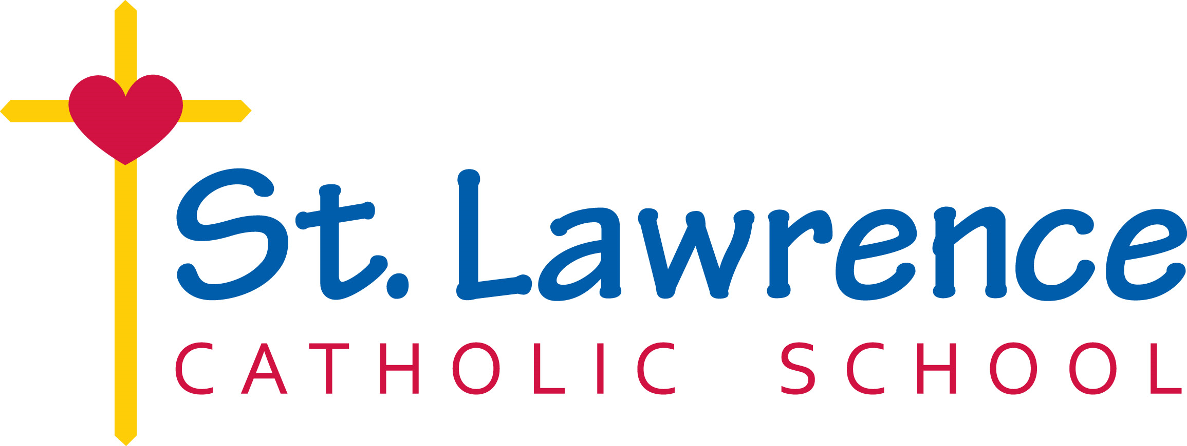
113 S. 6th St.
Milbank, SD 57252
Phone: (605)432-5673
Fax: (605)432-5846

Dear Applicant:

Thank you for your interest in St. Lawrence Catholic School.

ALL PARTS OF THE APPLICATION MUST BE COMPLETED. YOU MUST COMPLETE ALL ADDRESSES, ZIP CODES, PHONE NUMBERS, ETC. INCOMPLETE APPLICATIONS ARE NOT CONSIDERED. BE SURE YOU SIGN AND DATE THE APPLICATION AFTER CHECKING ALL YOUR INFORMATION.

The following materials are needed for your application to be complete:
1. Formal letter of application
2. Completed application form
3. Resume of work experience, educational background and related information
4. Copy of your South Dakota Teaching Certificate
5. Credentials from placement bureau OR three letters of recommendation
6. Copies of college or university transcripts

Completed applications will be screened for candidacy and will be retained in active files for one year. As positions become available for which you would like to be considered, please submit a letter of application specific to that position.

Please arrange to have your material sent to the following address:

St. Lawrence Catholic School
113 S. 6th St.
Milbank, SD 57252

Enclosures

